Did My Heart Love ‘til Now?
Matchmaker Profile

Insert Photo
Your Name
“Headline-Motto for your life, favorite quote, inspirational saying, etc.”

Source: www.
Describe yourself as if you were the scientist, including your personal, professional, and social life. How would others describe you? What accomplishments are you most proud of? What are you passionate about? In an effort to be a desirable individual, put a positive spin on any shortcomings the scientist may have. Use facts as the basis of this paragraph.
In My Own Words
Children:
From:
Favorite Things:
Religious Views:
Political Views:
Languages:
Education:
Looking For:
About Me

Did My Heart Love ‘til Now?
Matchmaker Profile

Robert Millikan
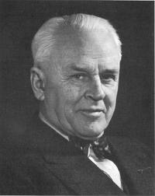
“ ”

Source: www.

In My Own Words
Family:
From:
Languages:
Favorite Scientific equipment and experiments:

Scientific Contribution:

Education:
Looking For:
About Me

Did My Heart Love ‘til Now?
Matchmaker Profile

John Dalton
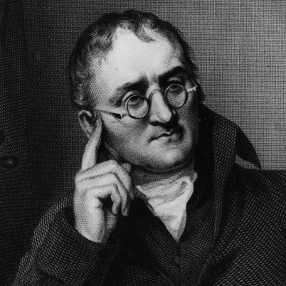
“ ”

Source: www.

In My Own Words
Family:
From:
Languages:
Favorite Scientific equipment and experiments:

Scientific Contribution:

Education:
Looking For:

About Me

Did My Heart Love ‘til Now?
Matchmaker Profile

Eugen Goldstein
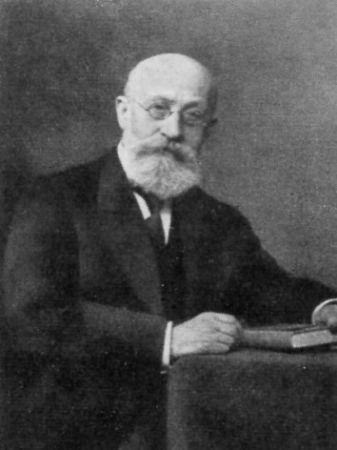
“ ”

Source: www.

In My Own Words
Family:
From:
Languages:
Favorite Scientific equipment and experiments:

Scientific Contribution:

Education:
Looking For:

About Me

Did My Heart Love ‘til Now?
Matchmaker Profile

James Chadwick
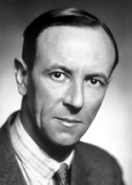
“ ”

Source: www.

In My Own Words
Family:
From:
Languages:
Favorite Scientific equipment and experiments:

Scientific Contribution:

Education:
Looking For:

About Me

Did My Heart Love ‘til Now?
Matchmaker Profile

Niels Bohr
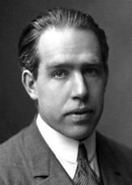
“ ”

Source: www.

In My Own Words
Family:
From:
Languages:
Favorite Scientific equipment and experiments:

Scientific Contribution:

Education:
Looking For:

About Me

Did My Heart Love ‘til Now?
Matchmaker Profile

J. J. Thomson
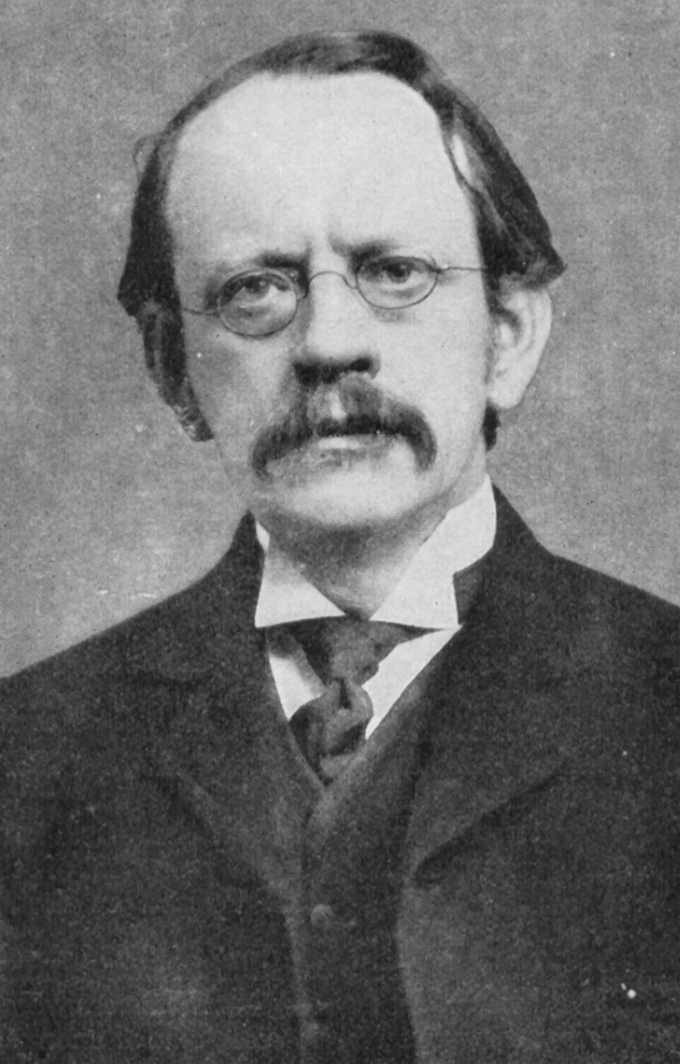
“ ”

Source: www.

In My Own Words
Family:
From:
Languages:
Favorite Scientific equipment and experiments:

Scientific Contribution:

Education:
Looking For:

About Me

Did My Heart Love ‘til Now?
Matchmaker Profile

Erwin Schrodinger
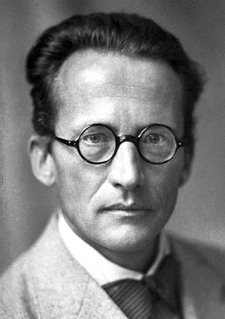
“ ”

Source: www.

In My Own Words
Family:
From:
Languages:
Favorite Scientific equipment and experiments:

Scientific Contribution:

Education:
Looking For:

About Me

Did My Heart Love ‘til Now?
Matchmaker Profile

Aristotle
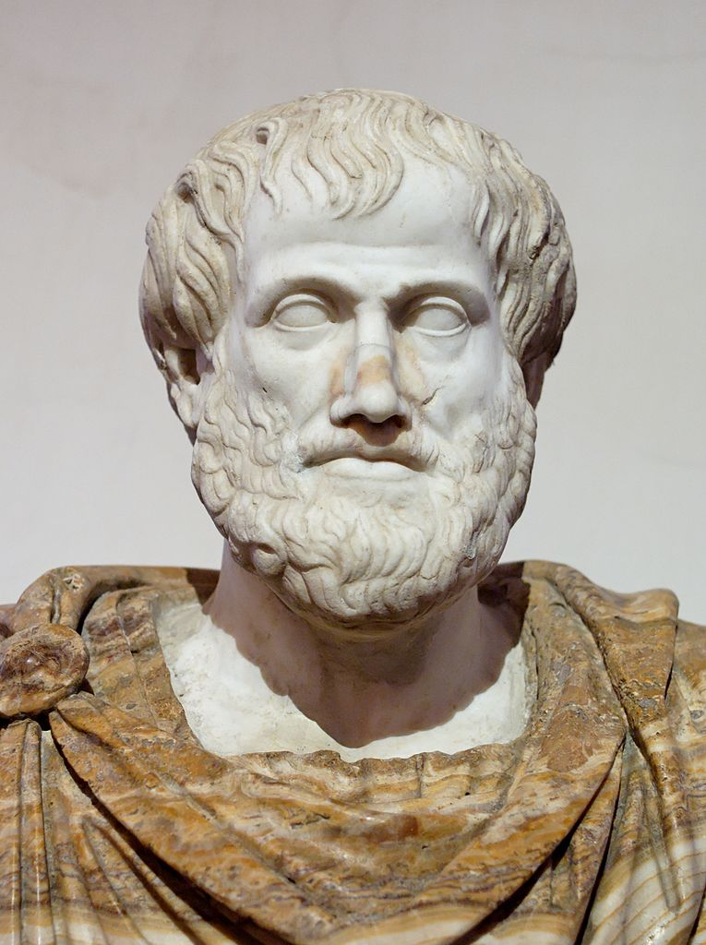
“ ”

Source: www.

In My Own Words
Family:
From:
Languages:
Favorite Scientific equipment and experiments:

Scientific Contribution:

Education:
Looking For:

About Me

Did My Heart Love ‘til Now?
Matchmaker Profile

Democritus
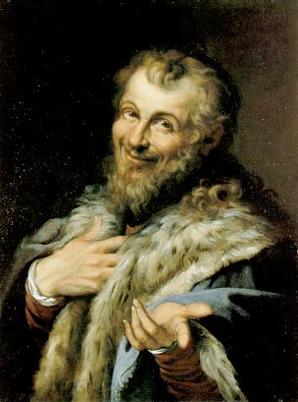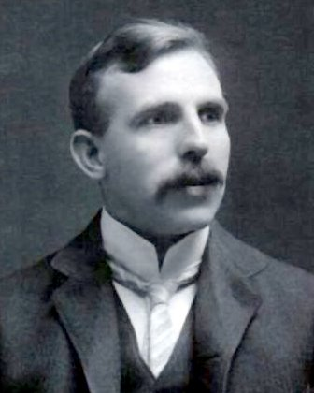
“ ”

Source: www.

In My Own Words
Family:
From:
Languages:
Favorite Scientific equipment and experiments:

Scientific Contribution:

Education:
Looking For:

About Me

Did My Heart Love ‘til Now?
Matchmaker Profile

Ernest Rutherford
“ ”

Source: www.

In My Own Words
Family:
From:
Languages:
Favorite Scientific equipment and experiments:

Scientific Contribution:

Education:
Looking For:

About Me

