AP BIO Chapter 16, 17, 18, 19 and 20 Exam Review
Chapter 16: DNA/The Molecular Basis of Inheritance
What functional group are DNA made of, how are they put together and what kind of bonds join the different parts?
What are the roles of DNA Polymerase III, DNA Polymerase I, Ligase, Helicase, RNA primer, and telomerase in DNA replication?
What determines the nucleotide sequence for a new strand of DNA?
How do leading strand and lagging strands differ?
What is the difference between heterochromatin and euchromatin?
What is the transformation of bacteria?
What direction is DNA synthesized?

Chapter 17: From Gene to Protein/Protein Synthesis
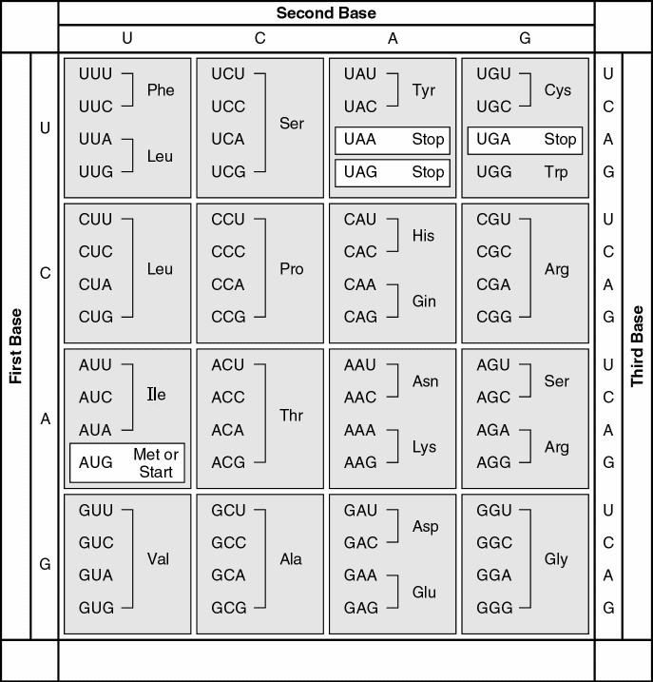
If there was a sequence of amino acids such as Arg-Glu-Val-Cys, what would the sequence of DNA that coded for them?
mRNA codons

What about if there was a sequence of mRNA codons such as ACUCAUGGAUUAUGA, what amino acids would they code for?
What are the roles of the TATA box, promotor, transcription factors, RNA polymerase, introns, exons, slicesosomes, 5' cap, Poly A tail, in Protein Synthesis and where are they found?
What type of bonds cause tRNA to be the odd shape that it is?
What are the steps of transcription and translation?
What is reverse transcription?
What is a polyribosome?
What are the different types of mutations? Which ones have the most serious effects?
How does protein synthesis differ in prokaryotes and eukaryotes?
Chapter 18: Regulation of Gene Expression
How does the tryptophan operon work? Is it an inducible operon or repressible operon? How do they differ? Be able to recognize and explain a model of this operon.
What are the roles of a promoter, repressor, inducer, activator and terminator in regulating gene expression? Recognize correct organization of these enzymes in a picture.
How are we able to have different types of cells in our body (cellular differentiation) when all of our cells have the exact same genetic information? How do cells remain differentiated?
What are cytoplasmic determinants?
Chapter 19: Viruses
What are retroviruses? What role does reverse transcriptase play in retroviruses?
What are the two viral cycles? What major events happen during each cycle?
What are nonspecific and specific processes that the human immune system carries out to protect the body from pathogens? How would various models of these processes compare?
What are various cells that play a role in the human immune system? What roles do they play?
Chapter 20: Biotechnology
What is bacterial transformation?
How do you prepare a gene and plasmid for transformation into a cell?
How are bacteria that have recombinant bacteria often identified?
When a gene is transformed into a bacteria, be able to determine which cultures the bacteria will grow on. Analyze bacterial transformation lab and other transformation data.
What are the steps for PCR? What is it used for?
What is a restriction enzyme? What is its role in biotechnology?
What is gel electrophoresis? What properties does it separate molecules based on? What types of molecules does it separate?
What is gene cloning?
If a segment of DNA was cut into pieces by a restriction enzyme and then run through a gel electrophoresis, what would the resulting gel look like? Which direction would the fragments move? Which fragments would move the furthest and which would move the least?

